The Short Courses’ Opens Championship 2019
Proudly sponsored by
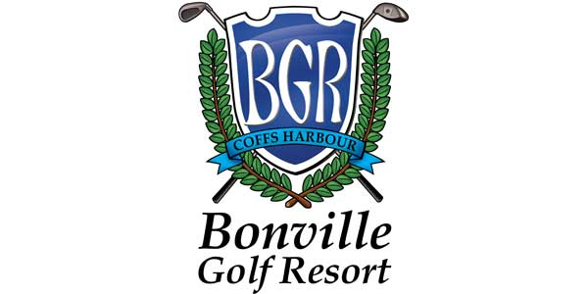
(02) 4964 8641
Come out and support your local clubs by simply participating in the 8 fun filled events at some of your local nine hole courses in 2019.
You only need your 4 best scores to become champion, but why not try more events with your mates, to increase your chances, and for a great day out!

CLUB DATE CONTACT
Stroud Open Sunday 17th February 4994 5264 Karuah Open/ Seafood Day Sunday 14th April 4997 5693
Wingham Open Sunday 5th May 6553 4761
Harrington Open Sunday 21st July 6556 0404 Paterson Open Sunday 22nd September 4938 5828
Bulahdelah Open Sunday 20th October 4997 4327
Gloucester Open Sunday 27th October 6558 1602
Dungog Open Sunday 3rd November 4992 1394
Presentation Day at Karuah Saturday 30th November 4997 5693

- Each event is played over 18 holes
- The winner of the scratch and net championships will be the player with the best four scores over the eight short course opens.
- The more rounds played, the better a player’s chance of their best four scores, eliminating their worst scores, after completing the minimum four eligible rounds.
- In the case of a tie (best four rounds), a players 5th and subsequent scores (if necessary) will be taken into account to determine a winner.
To check ongoing results log on to www.harringtonwatersgolfclub.com.au
“Get a group and enjoy the country hospitality of the short courses”

